Prerequisites :

1.Install Requests and SimpleJson Packages

2.WebApi Rest service with CRUD operations—deployed in IIS

Run the application :

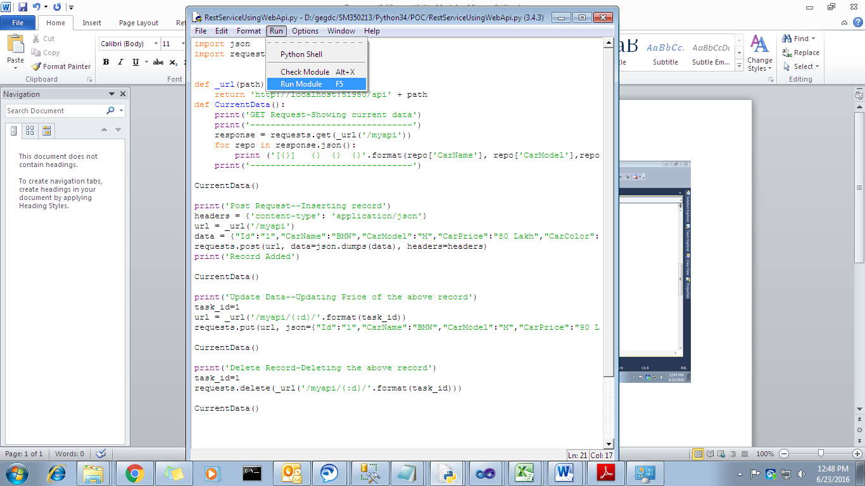

Output :

